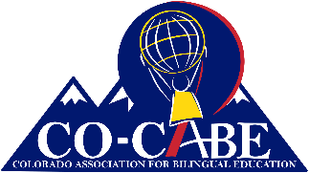
Colorado Association for Bilingual Education

Graduate Student Scholarship 2024

DESCRIPTION
$1,500 or $2500 for a Colorado graduate student pursuing a degree in education with a focus on Linguistically and Culturally Diverse Education.

ELIGIBILITY

Candidates must be accepted at an institution of higher education in Colorado.

Candidates must be enrolled in the summer or fall of 2024 and working towards a degree or certification in linguistically and Culturally Diverse Education in a Colorado university.

Previous winners of CO-CABE Scholarships and who meet the other eligibility requirements are eligible to apply.

Candidates receiving full scholarships or grants from other sources are not eligible for this scholarship.

Students who will complete their program before January 2024 are not eligible for this scholarship.

Candidates must submit all the required application materials prior to the application deadline in order to be considered.

Candidates who are bilingual and bicultural are encouraged to apply.

APPLICATION DEADLINE

The deadline for scholarship applications is 4 pm, May 3rd ,2024. Scholarship recipients will be notified by May 30, 2024.

Please submit completed scholarship applications electronically to:
info@cocabe.org

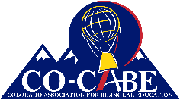
2024 CO-CABE Graduate Scholarship Application Instructions

The scholarship application consists of 4 parts. You must submit all of them for your application to be complete.
- Part I is the Information Sheet consisting of 10 questions.
- Part II is a separate sheet that lists community service, work experience, awards, and recognitions that you have received.
  - The committee is especially interested in your involvement with culturally and linguistically diverse communities.
  - Please provide a list.
- Part III is a three-page essay.
  - This essay should be typed, double spaced, 12 pt. font, with half inch margins on all four sides.
  - Read the essay instructions carefully and be sure to respond directly to the questions posed.
  - This essay is a critical piece of your application and is considered heavily by the Scholarship Committee.
- Part IV requires 2 signed letters of recommendation.
  - At least one letter of recommendation must be from an educator (teacher, professor, counselor, school administrator, etc. that knows your academic work).
  - Letters must be signed, scanned, and sent electronically.

APPLICATION DEADLINE

The deadline for scholarship applications is 4 pm, May 3rd, 2024. Scholarship recipients will be notified by May 30, 2024.

Please submit completed scholarship applications electronically to:
info@cocabe.org

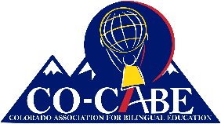
2022 CO-CABE Graduate Scholarship Application
Part I
Applicant Information

Applicant Name:

Mailing Address:
Parent/Guardian: (if age 17 or younger)
Phone:
E-Mail Address:
University:
Are you accepted to a university?  Yes☐ No☐ | If Yes, submit letter of acceptance
Are you accepted to a university?  Yes☐ No☐ | If No, submit a letter of acceptance when you receive it.
Are you enrolled? Yes☐ No☐ | If Yes, submit evidence of enrollment.
Are you enrolled? Yes☐ No☐ | If No, by when will you enroll?
Degree Program:
Are you working in a school?  Yes☐ No☐ | School Name:  District:  Your Position:
Percentage of Emerging Bilingual students in your school?
Are you Bilingual?  Yes☐ No☐ | If yes, in what languages?

APPLICATION DEADLINE The deadline for scholarship applications is 4 pm, May 3rd, 2024. Scholarship recipients will be notified by May 30, 2024.

Please submit completed scholarship applications electronically to:
info@cocabe.org

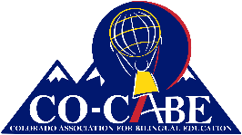
2022 CO-CABE Graduate Scholarship Application
Part II
List of Community Service & Awards

For Part II submit a separate sheet that lists community service, work experience, awards, and recognitions that you have received. The committee is especially interested in your involvement with culturally and linguistically diverse communities. Please provide a list, not a narrative, and be sure to include your name.
Part III
Essay
Part III is a thre- page (maximum) essay. This essay is a critical piece of your application and is considered heavily by the Scholarship Committee. Follow these instructions carefully and completely.
- This essay should be typed, double spaced, 12 pt. font, with half inch margins on all four sides.
- Please include a cover sheet that includes your name and a title for your essay. This page does not count towards the three page limit.
- There are 4 questions that you must respond to in your essay.
  - One: How did you come by your language(s)? For this question, provide a language autobiography describing how you have acquired your language(s).
  - Two: Why do you believe in Bilingual & Bicultural Education?
  - Three: What influences including people and/or events have led you to seek this degree?
  - Four: What do you plan to do with this education?

Part IV
Letters of Recommendation
You must submit 2 signed letters of recommendation.
- At least one letter of recommendation must be from an educator (teacher, professor, counselor, school administrator, etc. that knows you professionally or in an academic setting).
- Letters must be signed, scanned, and sent electronically.

APPLICATION DEADLINE

The deadline for scholarship applications is 4 pm, May 3rd, 2024. Scholarship recipients will be notified by May 30, 2024.

Please submit completed scholarship applications electronically to:
info@cocabe.org

